Vivekanand Education Society's Institute of Technology



Department of Computer Engineering

Group No.: 20
Date :- 10/08/2025

Project Synopsis Template (2025-26) - Sem VII

MailedIt : Your Effortless Email Marketing Platform
Mrs. Geocey Shejy
Assistant Professor , CMPN

Priya Anandai Rishi Daryani
2022.priya.anandani@ves.ac.in 2022.rishi.daryani@ves.ac.in

Om Goplani
d2022.om.goplani@ves.ac.in

Abstract
This project focuses on the development of a full-stack email marketing platform, MailedIt, inspired by Mailchimp. The system is designed to provide a comprehensive solution for marketers to manage their email campaigns and audience. The backend, built with Laravel, handles core services such as authentication, user management, subscriber segmentation, and a robust email sending engine. The frontend, developed using React, provides a modern and intuitive web interface, including a campaign creation wizard, a template editor, and an analytics dashboard. By combining these technologies, MailedIt offers a scalable, intelligent, and user-friendly platform for managing all aspects of email marketing operations, from content creation to performance tracking.

Introduction
MailedIt is a complete, full-stack email marketing solution that integrates a powerful Laravel backend with a dynamic React frontend. The system aims to replicate and improve upon the core functionalities of platforms like Mailchimp. The Laravel backend provides a secure and reliable foundation for data management, queue processing, and integration with third-party email services. The React frontend focuses on creating an exceptional user experience, offering a clear and efficient interface for marketers to perform complex tasks, ensuring the entire system is both robust and easy to use. This project will build a cohesive, decoupled, and scalable application.

Problem Statement
Email marketing remains a critical component of digital strategy, yet many existing solutions are either too complex, costly, or lack flexibility. The challenge is to build a full-stack application that addresses the entire workflow of an email marketer. This requires a robust backend to manage user data, campaign scheduling, and email delivery reliability, as well as an intuitive frontend to simplify campaign creation, audience management and performance analysis. The solution must integrate these components seamlessly to create an efficient and accurate platform that reduces manual effort and provides actionable insights.

Proposed Solution
MailedIt is a full-stack web application designed to empower marketers with a comprehensive set of tools, allowing for the creation and management of email marketing campaigns from a single, integrated platform. The system is built on a robust Laravel API backend that provides secure authentication and role-based access control, audience management APIs for creating and segmenting subscriber lists, and a powerful campaign engine. This engine leverages a job queue for reliable email dispatch through a third-party service like Mailgun or SendGrid. This backend is complemented by a responsive React frontend that offers an intuitive user interface, including a guided campaign creation wizard, a rich text editor for designing reusable email templates, and an analytics dashboard for tracking key performance metrics like open and click rates. This decoupled, full-stack approach ensures that all features are tightly integrated and optimized for a seamless and highly performant user experience.

Methodology
The project will follow a decoupled, component-based development approach. The development process begins with setting up the backend framework and configuring the environment to handle API endpoints for all core functionalities, including authentication, list management, and campaign actions. Queues and a dedicated worker will be implemented for background job processing such as email sending and deduplication, along with integration with third-party email sending services. Concurrently, the frontend development will focus on initializing the project and setting up client-side routing. Reusable components will be built for a consistent and responsive UI, connecting to the backend via an API client library. The UI will integrate a rich text editor for template design and a charting library for visualizing analytics.
To further improve the MailedIt platform, we could consider enhancing the automation builder with a visual drag-and-drop interface, making complex workflows more accessible to users. Additionally, integrating advanced analytics such as engagement heatmaps for emails and A/B testing functionality would provide marketers with deeper insights to optimize their campaigns. Implementing a more robust email deliverability score and inbox preview tool would also be a valuable enhancement for the platform's future growth.

Block Diagram :

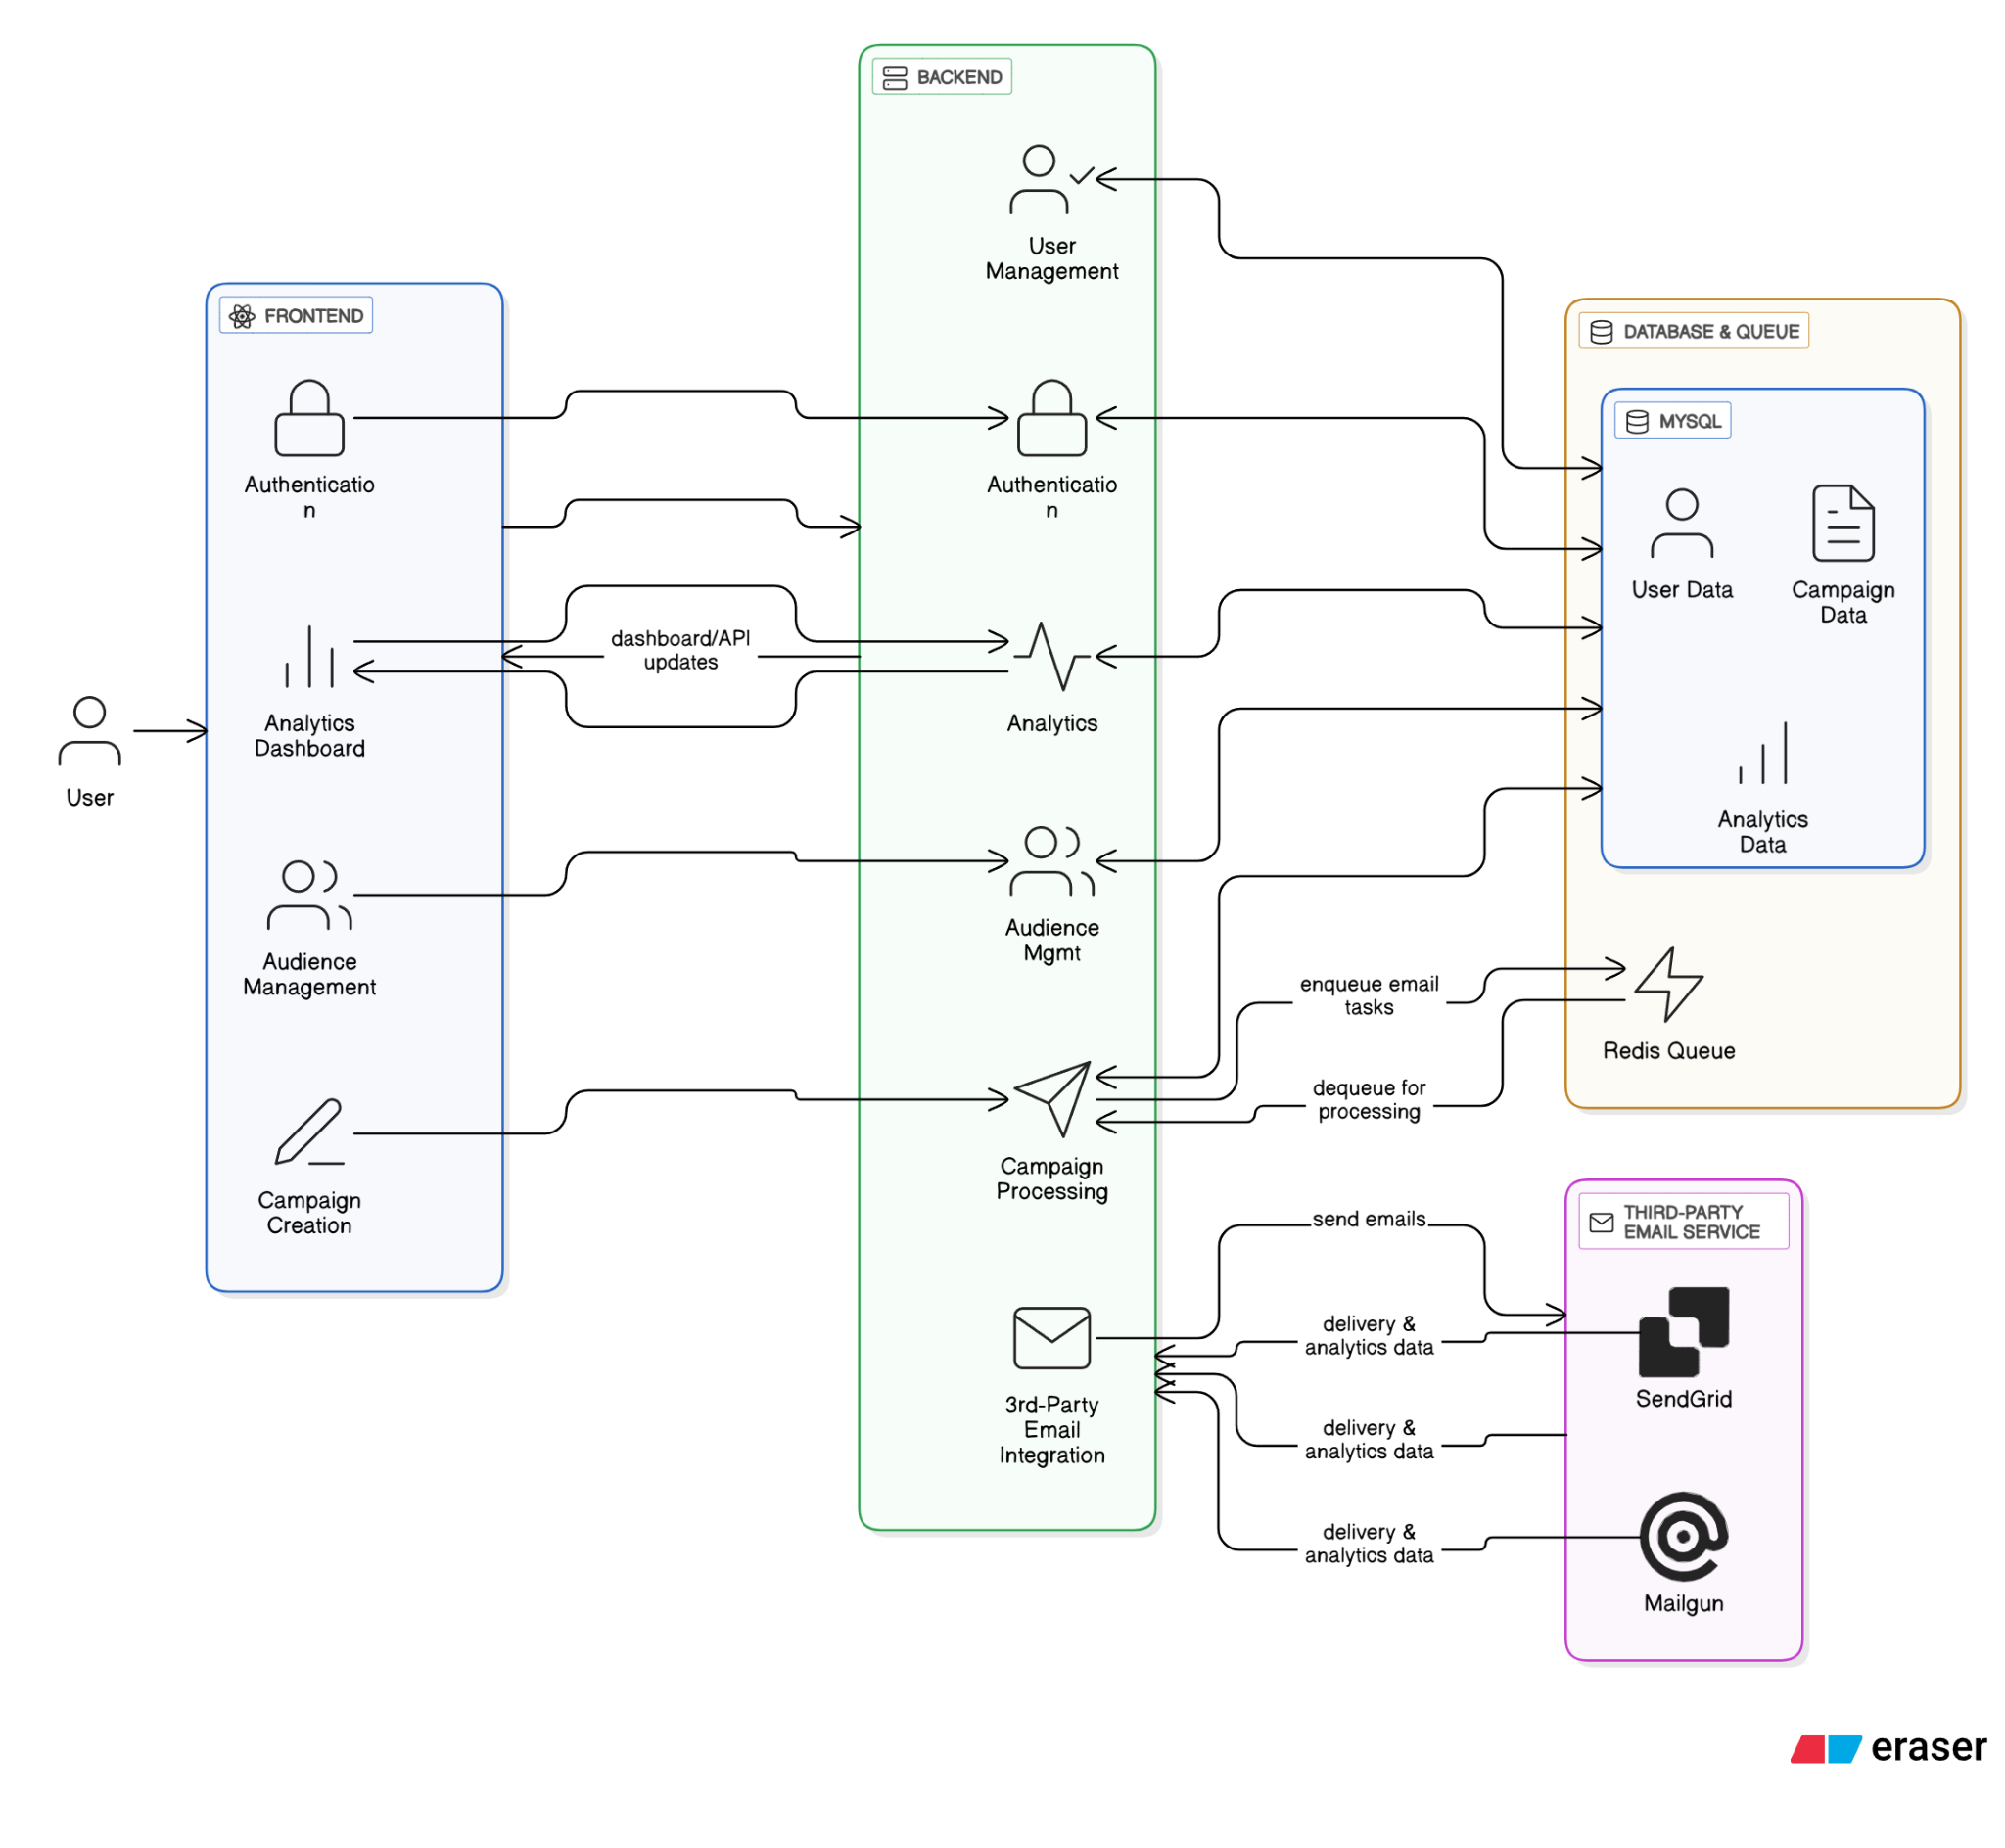
Fig. 1.1 Block diagram of the MailedIt Full-Stack Application

Hardware Requirements
- Processor: Intel i5 or higher
- RAM: Minimum 8GB
- Storage: Minimum 100GB HDD/SSD
- Internet Connection

Software Requirements
- OS: Windows 10 / Linux / macOS
- Backend: PHP 8.3+, Composer, MySQL, Redis
- Frontend: Node.js, npm/yarn
- Web Server: Nginx or Apache
- API Backend: Laravel 12
- API Authentication: Laravel Sanctum

Tools and Technologies
- Framework: Laravel 12 (Backend), React.js (Frontend)
- Language: PHP 8.3+, JavaScript, HTML/CSS
- Styling: Tailwind CSS
- Database: MySQL
- Queue/Cache: Redis, Laravel Horizon
- API Client: Axios

Proposed Evaluation Measures
- API Reliability: Uptime and response time of backend API endpoints.
- User Interface Responsiveness: The adaptability of the UI on different screen sizes and devices.
- Email Delivery Rate: The success rate of emails sent through the system.
- Feature Completion: The percentage of core MVP and optional features that are successfully implemented.
- User Satisfaction: Feedback from usability testing and surveys.

Implementation
- Backend Foundation: Set up the Laravel project, database, and initial authentication and user models.
- Frontend Foundation: Initialize the React project, set up routing, and create the core layout and navigation components.
- User Management: Build out the full user authentication flow on both the frontend and backend.
- Audience Management: Develop backend APIs for managing email lists and a corresponding frontend UI to interact with them.
- Campaign Core: Implement the full campaign creation, scheduling, and sending logic on the backend, and create the multi-step wizard and template editor on the frontend.
- Analytics & Automation: Build data tracking and reporting on the backend and create the visualization dashboards and simple automation UIs on the frontend.
- Testing & Deployment: Conduct comprehensive testing across the entire stack (unit, feature, E2E) and prepare the application for production deployment.

Comparative Study

Aspect | MailedIt | MailChimp | Campaign Monitor
Development Model | Full-stack, custom-built | Closed Platform,proprietary | Closed platform,proprietary
Customization | Full control over entire stack | Limited platform- provided options | Limited Customization
Integration | Custom API & service integrations | Extensive 3rd party integrations | Good range of integrations
Cost | Open-source,  self-hosted | Paid plans, free tier with limits | Paid, tiered pricing
Feature Set | Based on the defined roadmap | Comprehensive, but can be overwhelming | Strong core features, less advanced
Strengths | Modern full-stack tech,scalable,open source | Market leader, robust feature set | User-friendly,strong reporting
Limitations | Requires in-house dev team,self-hosting | Can be expensive, closed ecosystem | Less flexible, fewer advanced features
Recommendation | Ideal for a team needing scalable,custom solution with full control over the stack | Best for businesses needing a full-service,all-in one solution | Good for agencies and businesses needing simple,effective tools.

Conclusion
The MailedIt full-stack project successfully integrates a robust Laravel backend with a user-friendly React frontend to deliver a powerful and intuitive email marketing platform. By designing a decoupled yet cohesive architecture, the project provides a scalable foundation for managing email campaigns, audience data, and performance analytics. This approach offers significant potential for further development, including advanced automation and e-commerce integrations, ultimately providing a powerful tool for marketers to streamline their operations and enhance their campaigns.
References
[1] V. Sinha, V. Vinay, and H. Singh, “Modeling Time to Open of Emails with a Latent State for User Engagement Level,” arXiv, 2019. (arXiv)
[2] “May I have your attention, please? An investigation on opening effectiveness in e-mail marketing,” Review of Managerial Science, vol. 16, pp. 2261–2284, Apr. 2022. (SpringerLink)
[3] I. B. Mustapha et al., “Effective Email Spam Detection System using Extreme Gradient Boosting,” arXiv, Dec. 2020. (arXiv)
[4] C. Wei et al., “Neural Optimization with Adaptive Heuristics for Intelligent Marketing System,” arXiv, May 2024. (arXiv)
[5] S. Kotha, “The Transformative Impact of Artificial Intelligence and Machine Learning on Marketing Operations,” Int. J. Sci. Res. Comput. Sci. Eng. Inf. Technol., vol. 10, no. 6, pp. 176–182, Nov.–Dec. 2024. (ResearchGate)
[6] A. Kannan et al., “Smart Reply: Automated Response Suggestion for Email,” arXiv, Jun. 2016. (arXiv)
[7] Ayaz Nanji, “The Most Important Email Marketing Optimizations,” MarketingProfs, Dec. 2020. (MarketingProfs)
[8] Email statistics: segmentation and personalization impact, Sender.net, 2025. (Sender)
[9] AI-powered email personalization and ROI, Selzy (Twilio/McKinsey data), Selzy blog, 2023. (Selzy)
[10] AI-driven email marketing statistics: open rates, automation ROI, Alore blog, 2025. (Alore)
[11] Video in email campaigns (click-through boost), Wikipedia – Video email, ~2023-2024. (Wikipedia)
[12] “The Evolution of Email Deliverability: From Basics to AI-Driven Insights,” Customers.ai blog, 2025. (Customers.ai)
[13] Email A/B testing effectiveness (open & click-through increases), Charle Agency – Email Marketing Statistics, 2025. (Charle Agency)
[14] Features of email marketing automation (segmentation, personalization, analytics), Wikipedia – Marketing automation in email campaigns, 2025. (Wikipedia)
[15] Reddit user insights on predictive analytics, automation workflows, dynamic content blocks in email marketing, r/Emailmarketing, ~2023. (Reddit)
[16] Reddit observations on mobile optimization, AI, interactive content trends, r/Emailmarketing, ~2022. (Reddit)
[17] Reddit discussion on emerging trends for 2025—advanced personalization, privacy, UGC, accessibility—in email content, r/EmailMarketingMastery, Nov. 2024. (Reddit)
[18] Reddit best practices: clear CTAs, visuals, A/B testing, optimized sending times, r/MarketingResearch, ~2023. (Reddit)

